SIMATS ENGINEERING

ASSESSMENT TOOL 1

COURSE NAME: INTERNET PROGRAMMING COURSE CODE: CSA43

COURSE OUTCOME COVERED

CO 3: Implement dynamic web applications by utilizing DOM-based client-side scripting and employing Java Servlets for server-side request processing and response handling. (L3)

Assessment Tool : Scenario-Based Assessment

Weightage: 40%

QUESTIONS: Total Marks: 30

Question 1
Suppose that a college wants to develop an online student registration system where students submit their details through a web form, and the data is processed using a Java Servlet.
Explain the architecture of a servlet-based application. Design and implement a servlet to handle form data using both GET and POST methods. Describe the servlet life cycle (init, service, destroy) and justify which method is more appropriate for handling sensitive data.

Answer
Servlet-based application architecture: A servlet web application mainly contains a client/browser, web server or servlet container such as Apache Tomcat, Java Servlet classes, and a database when persistent storage is required. The browser sends an HTTP request to the server.
Tomcat receives the request, finds the required servlet, and calls the appropriate method such as doGet() or doPost(). The servlet processes the data and sends an HTTP response back to the browser.

Basic flow
Browser ® HTTP Request ® Tomcat/Servlet Container ® Servlet ® Processing/Database ® HTTP Response ® Browser

Servlet using GET and POST
import java.io.IOException;
import jakarta.servlet.ServletException; import jakarta.servlet.annotation.WebServlet; import jakarta.servlet.http.HttpServlet;
import jakarta.servlet.http.HttpServletRequest; import jakarta.servlet.http.HttpServletResponse;

@WebServlet("/StudentServlet")
public class StudentServlet extends HttpServlet {

protected void doGet(HttpServletRequest request,
HttpServletResponse response) throws ServletException, IOException {

String name = request.getParameter("name"); response.getWriter().println("GET received: " + name);
}

protected void doPost(HttpServletRequest request,
HttpServletResponse response) throws ServletException, IOException {

String name = request.getParameter("name"); String email = request.getParameter("email");

response.getWriter().println("Student Name: " + name); response.getWriter().println("Email: " + email);
}
}

Servlet life cycle
- init(): Called once when the servlet is created. It is used for initialization tasks.
- service(): Called for each client request. It determines whether doGet(), doPost(), or another HTTP method should handle the request.
- destroy(): Called once before the servlet is removed from service. It is used for cleanup tasks.

GET vs POST for sensitive data
POST is more appropriate for sensitive data such as passwords and personal registration information. GET places submitted values in the URL, where they may appear in browser history, bookmarks, logs, and other locations. POST sends the form data in the request body and is therefore preferable for form submission involving sensitive information. For real applications, HTTPS should also be used because POST by itself does not encrypt data.

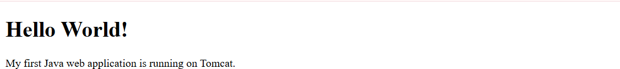

Question 2
Suppose that a website requires users to log in and maintain their session across multiple pages after authentication.
Design a session management system using HttpSession and Cookies in Servlets. Explain how session tracking works in web applications and compare session-based tracking with cookies.

Answer
Session management allows a web application to remember a user after login. HTTP is stateless, so each request is independent unless the application uses a session-tracking mechanism. HttpSession can store user information on the server, while a cookie can store a small identifier in the user's browser.

Login servlet using HttpSession
import java.io.IOException;
import jakarta.servlet.ServletException; import jakarta.servlet.annotation.WebServlet; import jakarta.servlet.http.HttpServlet;
import jakarta.servlet.http.HttpServletRequest; import jakarta.servlet.http.HttpServletResponse; import jakarta.servlet.http.HttpSession;

@WebServlet("/LoginServlet")
public class LoginServlet extends HttpServlet { protected void doPost(HttpServletRequest request,

HttpServletResponse response) throws ServletException, IOException {

String username = request.getParameter("username"); String password = request.getParameter("password");

if (username.equals("admin") && password.equals("1234")) {

HttpSession session = request.getSession(); session.setAttribute("username", username);

response.sendRedirect("HomeServlet");

} else {
response.getWriter().println("Invalid Login");
}
}
}

Home servlet – checking the session
HttpSession session = request.getSession(false);

if (session != null && session.getAttribute("username") != null)
{

response.getWriter().println(
"Welcome " + session.getAttribute("username"));

} else {
response.sendRedirect("login.html");
}

Using a Cookie
Cookie cookie = new Cookie("username", "admin"); response.addCookie(cookie);

How session tracking works

- The user logs in.
- The server creates an HttpSession.
- A session ID is associated with the user's browser, commonly through a cookie such as JSESSIONID.
- The browser sends the session identifier with later requests.
- The server uses the identifier to find the user's session data.
- After logout, the session can be invalidated.

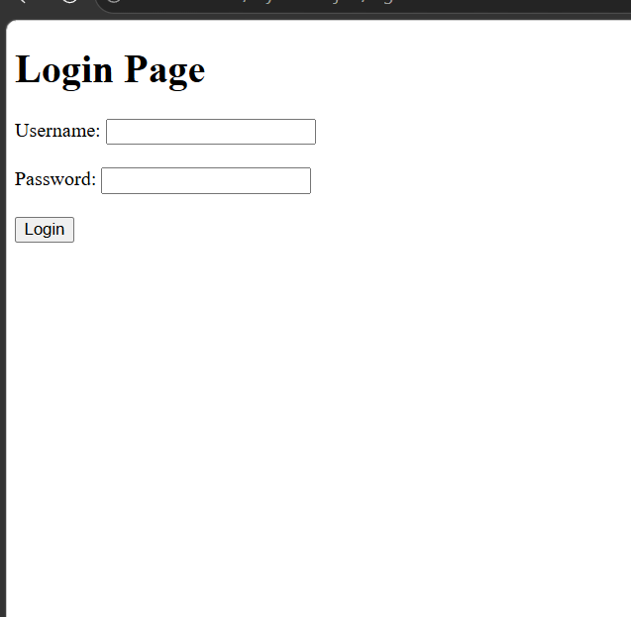

Question 3
Suppose that an e-commerce platform needs to store and retrieve product details from a database using a Java-based web application.
Design a JDBC-based application to connect to a database, insert product data, and retrieve it using SQL queries. Explain the JDBC architecture and describe the steps involved in database connectivity along with proper exception handling.

Answer
JDBC (Java Database Connectivity) is an API used by Java applications to communicate with relational databases such as MySQL. In a web application, a servlet can receive product information from an HTML form, use JDBC to connect to MySQL, execute an INSERT statement, and later execute a SELECT statement to retrieve products.

JDBC architecture
Java Servlet/Application ® JDBC API ® MySQL JDBC Driver ® MySQL Database
The JDBC API provides classes and interfaces such as Connection, PreparedStatement, and ResultSet. The MySQL Connector/J driver translates JDBC calls into commands understood by MySQL.

Steps in JDBC database connectivity
- Load/register the driver: Make the MySQL Connector/J driver available to the application.
- Establish connection: Use DriverManager.getConnection() with the database URL, username, and password.
- Create a statement: Use PreparedStatement for parameterized SQL.
- Execute SQL: Use executeUpdate() for INSERT/UPDATE/DELETE and executeQuery() for SELECT.
- Process the result: Read rows from ResultSet.
- Close resources: Close ResultSet, PreparedStatement, and Connection, preferably using try-with-resources.

Database table
CREATE DATABASE shop;

USE shop;

CREATE TABLE product (
id INT PRIMARY KEY AUTO_INCREMENT, name VARCHAR(100),
price DOUBLE, quantity INT
);

Simple ProductServlet – Insert and Retrieve
import java.io.IOException;
import java.io.PrintWriter;
import java.sql.Connection; import java.sql.DriverManager;
import java.sql.PreparedStatement; import java.sql.ResultSet;

import jakarta.servlet.ServletException; import jakarta.servlet.annotation.WebServlet; import jakarta.servlet.http.HttpServlet;
import jakarta.servlet.http.HttpServletRequest; import jakarta.servlet.http.HttpServletResponse;

@WebServlet("/ProductServlet")
public class ProductServlet extends HttpServlet {

protected void doPost(HttpServletRequest request,
HttpServletResponse response) throws ServletException, IOException {

String name = request.getParameter("name");
double price = Double.parseDouble(request.getParameter("price")); int quantity = Integer.parseInt(request.getParameter("quantity"));

String url = "jdbc:mysql://localhost:3306/shop"; String user = "root";
String password = "root";

String sql = "INSERT INTO product(name, price, quantity) " + "VALUES (?, ?, ?)";

try (Connection con =
DriverManager.getConnection ( url, user, password);
PreparedStatement ps = con.prepareStatement(sql)) {

ps.setString(1, name);
ps.setDouble(2, price); ps.setInt(3, quantity); ps.executeUpdate();
response.getWriter().println( "Product added successfully");
} catch (Exception e) { e.printStackTrace(); response.getWriter().println( "Database Error: " + e.getMessage());
}
}

protected void doGet(HttpServletRequest request,
HttpServletResponse response) throws ServletException, IOException {

response.setContentType("text/html"); PrintWriter out = response.getWriter();

String url = "jdbc:mysql://localhost:3306/shop"; String user = "root";
String password = "root";

String sql = "SELECT * FROM product";

try (Connection con =
DriverManager.getConnection ( url, user, password);
PreparedStatement ps = con.prepareStatement(sql); ResultSet rs = ps.executeQuery()) {
out.println("<h2>Products</h2>"); while (rs.next()) {
out.println(
rs.getInt("id") + " " + rs.getString("name") + " " + rs.getDouble("price") + " " + rs.getInt("quantity") + "<br>");
}

} catch (Exception e) { e.printStackTrace();
out.println("Database Error: " + e.getMessage());
}

}
}

HTML form for ProductServlet
<form action="ProductServlet" method="post">

Product Name:
<input type="text" name="name"><br><br>

Price:
<input type="text" name="price"><br><br>

Quantity:
<input type="text" name="quantity"><br><br>

<input type="submit" value="Add Product">

</form>

<a href="ProductServlet">View Products</a>

Exception handling
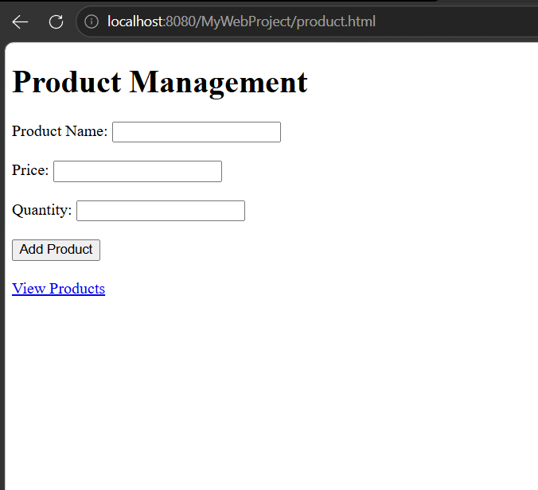
JDBC operations can fail because of an incorrect database URL, wrong username/password, missing JDBC driver, invalid SQL, or database connection problems. The try-catch block handles these exceptions and prevents the application from terminating unexpectedly. Try-with-resources automatically closes JDBC resources after use.

Code of Conduct:

I V Aswini Pavan Kumar (192372151) (Name / Reg No) certify that this submission is my original work and that I have adhered to the guidelines specified for this assessment. I understand that any violation of academic integrity rules will result in disciplinary action.

Signature of the student:

RUBRICS FOR CALCULATION:
Criteria | Weighta ge (%) | Level 4 (Exemplary) | Level 3 (Proficient) | Level 2 (Developing) | Level 1 (Beginning)
Understandi ng of Scenario | 20% | Demonstrates clear and complete understanding of the scenario and context | Shows good understanding with minor gaps | Partial understandi ng; misses key aspects | Misinterprets or fails to understand the scenario
Identification of Key Issues | 20% | Accurately identifies all relevant issues and factors involved | Identifies most key issues with  minor omissions | Identifies limited issues; some  irrelevant points | Unable to identify key issues
Application of Concepts | 25% | Applies appropriate concepts effectively to address the scenario | Applies concepts with minor errors | Limited or partially correct application | Unable to apply relevant concepts
Decision Making | 20% | Makes well reasoned, logical decisions with strong rationale | Makes reasonable decisions with some justification | Makes weak decisions with limited justification | No clear decisions made or rationale provided
Clarity of Response | 15% | Response is clear, structured, and  logically presented | Generally clear with minor issues | Somewhat unclear or poorly structured | Disorganize d and difficult to understand

